Morgan Conservation District 2019 Annual Report
Overview:
Throughout the duration of 2019, Morgan Conservation District has organized and hosted a variety of events within the Morgan County Community. All efforts of the District are towards conserving, preserving, and utilizing the natural resources to the best extent. Much of the District’s efforts include communicating with landowners to better understand how the District, and other agencies, can help them in continuing the District’s mission of locally led conservation.
Finances:
The District’s primary sources of income are in the forms of County assistance, Direct assistance from the State, conservation tree seedling and tree planting supplies sales, and grass seed sales. During 2019, the District increased the number of trees sold from 2018 by approximately 1,000 trees, resulting in an increased income of approximately $5,000. Additionally, sales of tree planting supplies such as staples, fabric, polymer, and fertilizer increased by approximately $8,000.
The primary expenses for the District are payroll and employee benefits, employer taxes, and the cost of trees and tree planting supplies. Expenses associated with trees have decreased by approximately $700 from 2018 to 2019, but expenses associated with payroll has increased approximately $25,000.
Grants:
There were two operational grants in place during 2019. The first was the National Association of Conservation District’s (NACD) Technical Assistance grant, designed specifically as a partnership grant between NACD and the Natural Resources Conservation Service (NRCS) to better assist and enhance efforts in conservation district technical assistance across the nation. Morgan Conservation District employed two technicians under the first round of the grant fund. A second application was submitted and awarded, however, due to difficulty in finding qualified applicants, the District returned the second round of funding to NACD. Additionally, the District refunded a portion of an unused grant which paid for a District Technician from May 2018 to July 2019.
The second grant was the Colorado State Conservation Board’s (CSCB) Matching Grants Program. An application for this grant was submitted and awarded in 2018. Under this grant, the District applied for matching grant funds to host a variety of workshops for landowners in Morgan County. The following workshops took place in 2019:
Bat House Workshop with Local Boy Scouts Troop – September 14th, 2019
Approximately 15 participants attended the workshop. 30 bat houses were made. More information can be found in the 2019 Fall Newsletter or at NACD’s blog here: https://www.nacdnet.org/2019/10/29/celebrating-and-conserving-bats/
Drip Irrigation Tour – September 25th, 2019
Approximately 21 attendees were at this workshop. Many of them were curious regarding the logistics of installing and maintaining a drip irrigation system. Vendors from various companies like Rivulis spoke upon different SDI setups.
Noxious Weed and Pesticide Applicator Workshop – October 23rd, 2019
Approximately 17 attendees came to this workshop – from Fort Morgan to Denver to Laramie. Sandra McDonald from Mountain West Pest spoke on various topics regarding noxious weed management and information for pesticide applicators. Attendees expressed how helpful the workshop was for them.
Wheat Growers Forum – November 8th, 2019
Approximately 15 attendees came to this workshop. The District partnered with the local Extension office to host this workshop. Wilma Trujillo, Area Agronomist Agent for Logan and Morgan Counties led the discussion regarding the origins of wheat stem sawfly, how to treat it, and management practices for wheat producers. Several producers spoke on their personal experiences with sawfly and brainstormed ways to possibly mitigate the pest.
The District is currently awaiting on approval for a Targeted Conservation Project grant application. The District partnered with Centennial Conservation District of Logan County to request federal grant dollars for projects and incentives for landowners regarding pheasant habitat on pivot corners.
Additionally, there have been discussions regarding the Lower South Platte Watershed (Morgan, Logan, Phillips, and Sedgwick Counties) applying for a Conservation Innovation Grant or a different Targeted Conservation Project for either a water quality and quantity issue or a noxious weed issue. A roundtable met in September 2019 to discuss project ideas and ways to educate landowners within the community. Currently, the Centennial Conservation District and Morgan Conservation District have partnered together to host a Salinity Workshop in January 2020 in Sterling to educate landowners and gauge interest for future salinity projects.
Projects and Programs:
As per tradition, the annual conservation tree seedling sale took place in Spring 2019. A total of 6,291 trees were sold and distributed to citizens of Morgan County. Currently, the District offers trees and grass seed mixes on the District’s website. In doing so, the District will also be able to sell grass seed and trees with a mobile phone at events like local fairs, ag expos, and farm days.
The District contacted local school teachers in May to invite them and their students to initiative participation in Colorado Association of Conservation District’s (CACD) 2019 poster contest. No final decisions have been made at this time.
However, the District has been in contact with a science teacher from Green Acres Elementary School to initiate and help support a Garden Project at the school. Funding opportunities are being explored by the District to assist with the project. Additionally, the District is volunteering time and resources to help with the project.
Currently, the District is in discussions with the local CSU Extension office to participate in the 2020 Safety Day.
Additionally, the District has discussed the possibility of partnering with Morgan Community College to host a variety of workshops on drones in agriculture, as well as collecting soil and water samples for projects related to such areas.
Another project was introduced to the District by Laura Tyler of Fort Collins Conservation District. Currently, Laura is managing a grant awarded by the State of Colorado to collect baling twine for recycling. The District is working with local dairies, agricultural shops, and feed yards to set up collection bins for baling twine to then clean, sort, and recycle them with the help of local 4H and FFA groups.
The District is also helping support and organize the 2020 Farming Evolution Conference in Holyoke, Colorado. In 2019, the District aided in organizing and presenting the 2019 Farming Evolution Conference.
Community Outreach:
The District started off the year with their Annual Meeting at Country Steak Out in Fort Morgan, Colorado. Kara Harders from Colorado Small Acreage spoke on rotational grazing, drought management, and a new grazing method called “paddock paradise”. A total of 57 people attended the meeting, approximately twice the number of attendees from the 2018 meeting. Additionally, sponsorships increased 200% from the 2018 meeting.
In April, the District partnered with CSU Extension and a few local 4-H groups to clean up Riverside Park of trash and debris. Over 20 volunteers and parents participated and were able to collect 10 bags of trash from the park and Nature Trail.
In May, the District visited Columbine Elementary School for the Outdoor Education Day with the Riparian Trailer. Students were able to view a stimulated floodplain and mimic the affects of flooding on the riverbank and soils.
Additionally, a $1,000 college scholarship was awarded to Devin Gerken in May.
In June, The District hosted their annual Locally Led Workgroup Meeting. Approximately 20 landowners participated and voiced many of their conservation concerns. Primary concerns included salinity and nutrient pollution issues developing within the South Platte River, the use of new technologies/drones in agriculture, noxious weed management, and the effect of increasing populations on rural land and agriculture.
In July, the District sponsored a 3-part Private Lands Wildlife Habitat Tour Workshop through Logan, Phillips, and Morgan Counties. The workshop in Morgan County focused on cheatgrass control and sand sage habitat management.
In October and November, the District helped 4H and FFA groups with Baling Twine workdays as a part of the Baling Twine Recycling program.
In December, Kendra Filter was awarded a $250 Walmart gift card for winning the Agricultural Video Contest.
Other:
Other activities and operations of the District include the following:
- Hosted 2019 Lower South Platte Watershed Association Annual Meeting
- Attended 2019 Colorado Association of Conservation Districts Annual Meeting
- Attended 2019 Colorado Ag Water Alliance Summit
- Provided 10 soil maps to assist in Planning & Zoning permitting process
Upcoming Grants, Workshops, and Events:
The District is currently researching or organizing the following projects and ideas:
- Co-hosting a Salinity Workshop in January 2020 in coordination with Centennial & Sedgwick County Conservation Districts and Morgan, Logan, Julesburg NRCS offices
- Initiating pollinator cost-shares or an incentivized program (may include cost-share for beekeeping, pollinator seedings/habitat, or other technologies)
- Partnering with local community gardens & schools to provide fresh foods to youth
- Installing a Boot Brush Kiosk at Riverside Park in partnership with the Fort Morgan Parks Department
- Initiating & co-hosting a traveling Soilsfest or Waterfest within the Lower South Platte Watershed Association
- Applying for Non-Point Source Mini Grants for water quality & quantity projects
- Applying for CSCB grants for projects on the Lower South Platte River or within the Lower South Platte Watershed Association
- Resuming Noxious Weed meetings, hosting workshops, and contributing to the 2020 County Noxious Weed Management Plan
- Researching and applying for Regenerative Agriculture grants and technologies
- Implementing Soil Health incentives or cost-share programs
- Reestablishing pheasant habitat plantings with local youth groups
- Initiating Arbor Day/Tree Workshops with local youth groups and elementary schools
- Continuation of annual Earth Day clean-up with youth volunteers
- Initiating Artificial Intelligence/Drone workshops
- Selling sub-surface drip irrigation equipment to landowners
- Creating & distributing rain barrels to landowners
- Reestablishing County windbreaks and living snow fences
- Pursuing a Conservation Innovation Grant with NRCS to implement new technologies in water conservation and preservation
- Collaborating with agencies focused on carbon sequestration to provide landowners with information and resources to implement such programs
A few moments from 2019:
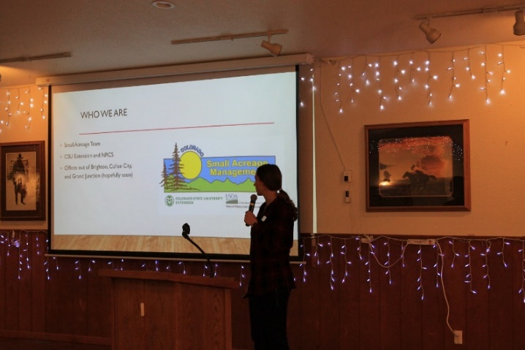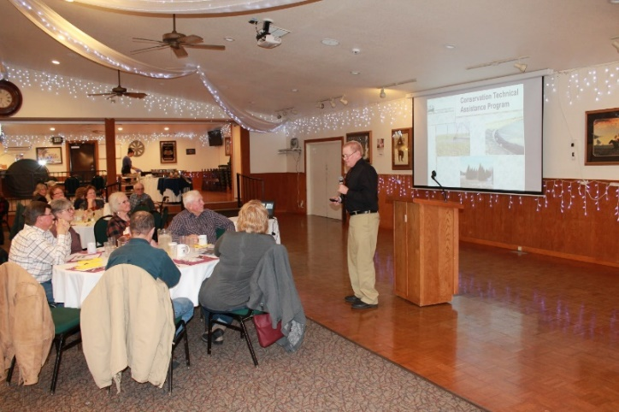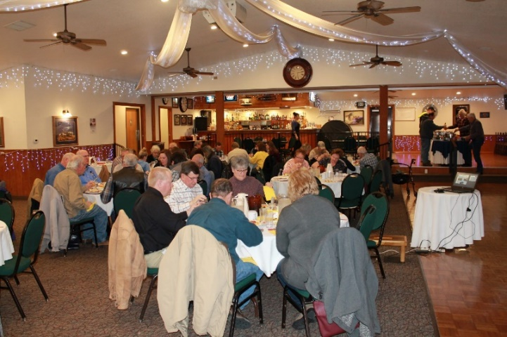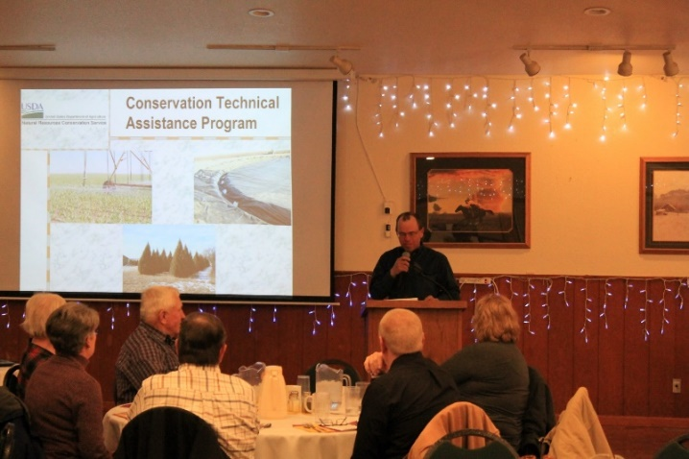
Pictures from the District’s 2019 Annual Meeting. Kara Harders from CSU’s Small Acreage Office (top left) spoke on range and pasture management. C.W. Scott (top right) from Fort Morgan NRCS spoke on the Conservation Technical Assistance Program. Todd Wickstrom (bottom right), Board President, gave introductions.
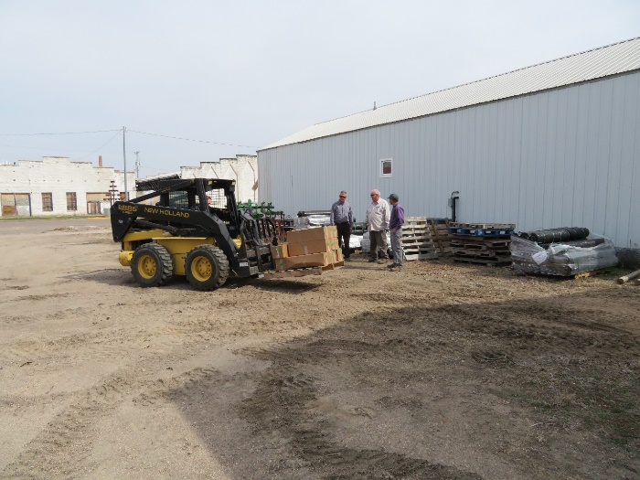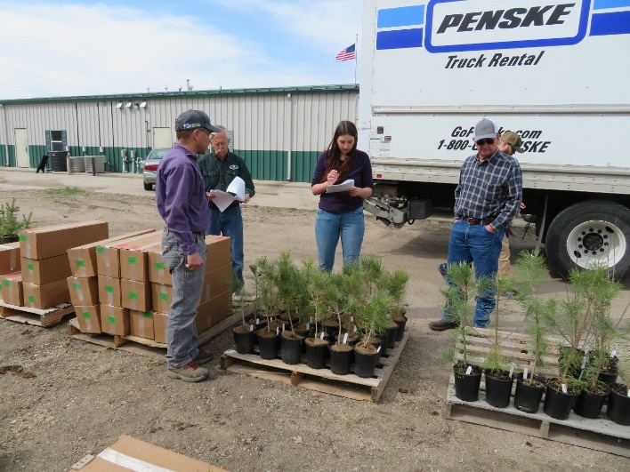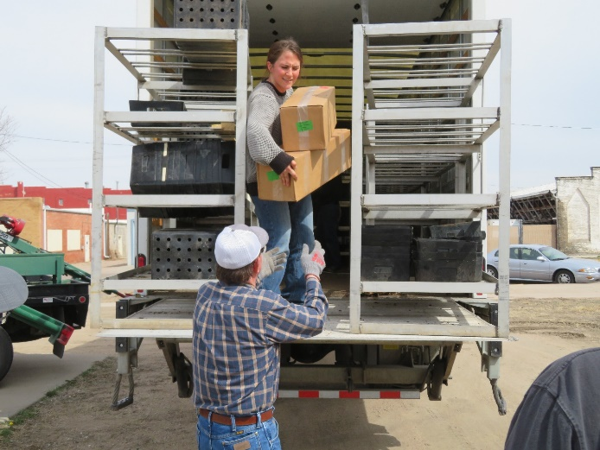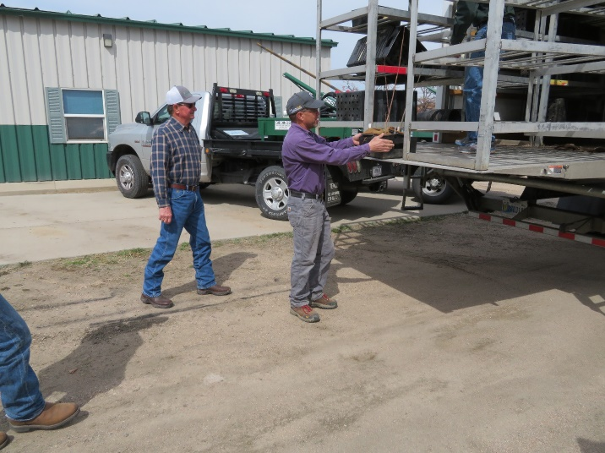
A few pictures from 2019’s Tree Delivery Day. Supervisors on the Morgan Conservation District Board, District employees, and NRCS staff assisted with unloading and counting trees.
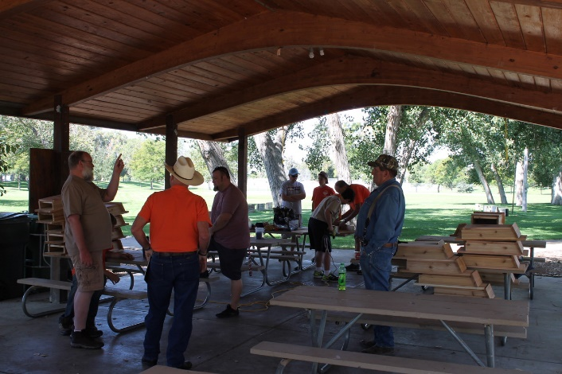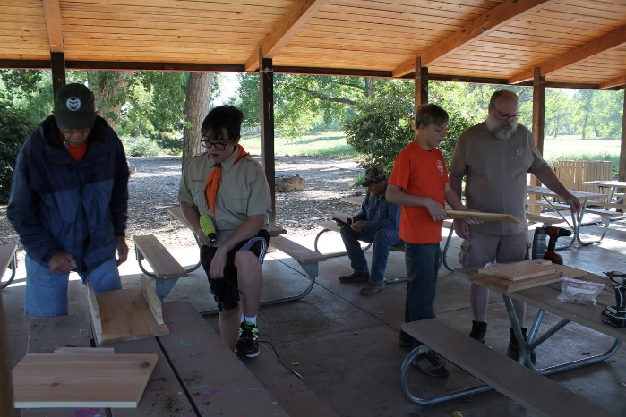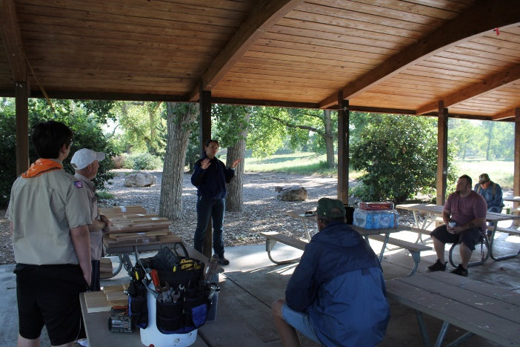
On September 14th, 2019 the Conservation District partnered with Boy Scouts Troop #22 to host a bat house workshop at Riverside Park in Fort Morgan, CO. The workshop was funded by a CSCB (Colorado State Conservation Board) matching grant. Volunteers made approximately 30 bat houses!

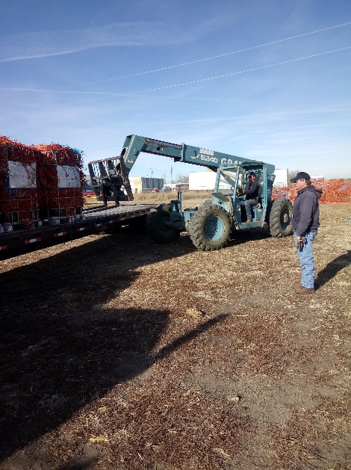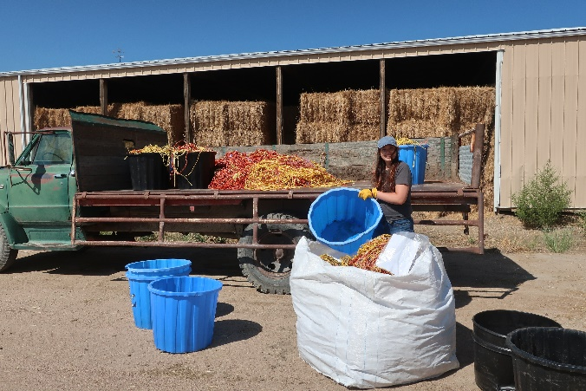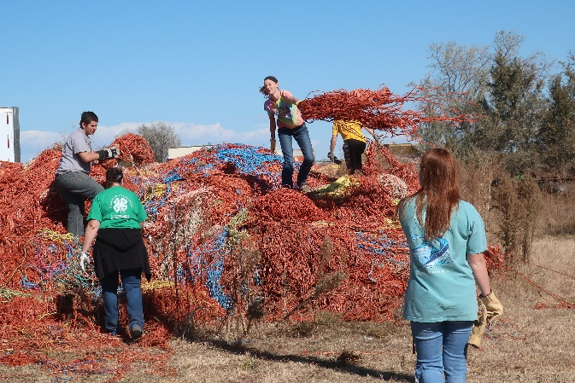
A few pictures from our 2019 Baling Twine Adventures. We partnered with Morgan County 4H Exchange and Fort Morgan FFA to clean and sort the twine, and then Buchanan’s Welding & Construction helped us sort it!

If you have suggestions or comments, please contact Morgan Conservation District at
970-427-3362 or morganconservationdistrict@gmail.com

